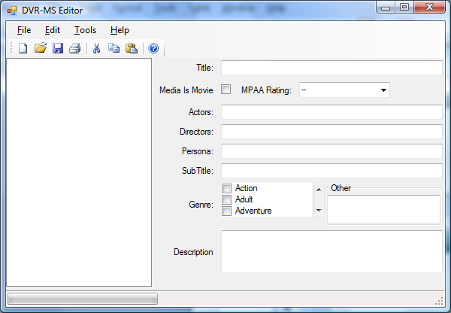
1) Select File|Open

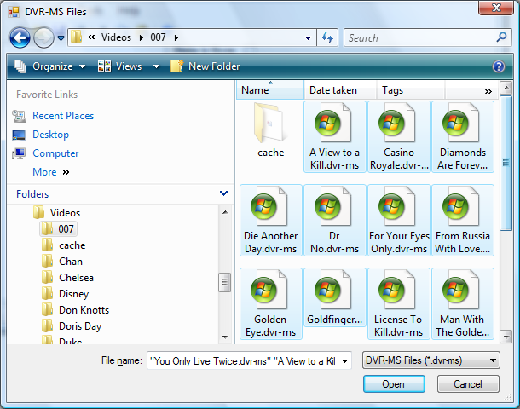
2) Select your dvr-ms files, and click Open

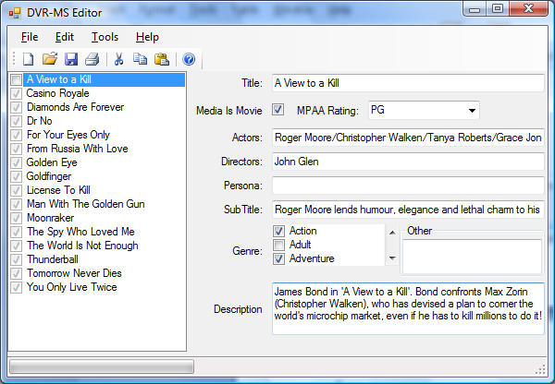
As you select each file in the list box the CheckState is changed to indicate that the MetaData has been loaded. A subset of the MetaData is presented in the editable panel on the right.

